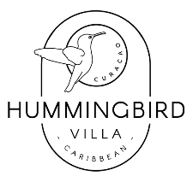
Using the Hummingbird Villa Phone
Please enjoy mobile phone. Here are some points:
Top-up:
- To use the phone you will need to recommence the data service:
- On the phone go to ‘Messages’ and locate a dialogue with number 3434
- Send a new message ‘SURF30DL’
- When prompted send a further message “A”
- If you get a negative response like ‘Insufficient funds’ message Jon and he can kick it off remotely

Using the Mobile Data from the Phone Rather than your Expensive Home Phone:
- The house phone works much better than your home mobile, particularly at places like Delboy (‘Daaibooi’) Beach. You can even connect your own phone to the house phone to use that data instead as per below:
- On the house phone go to Settings (cogwheel) > Connections > Mobile Hotspot and Tethering > Mobile Hotspot (use the slider to switch it on, but also click the words so you can see the Hotspot name (’HUMM’ and the password)
- Now access the HUMM WiFi hotspot from your own phone

Google Maps:
Use Google maps on the gold mobile phone provided for navigation. The whole of Curacao is cached, so it should not require network access to function. When you’re back home ensure it is cached properly by pressing the three-line menu button top-left in Google Maps, then choose ‘Offline maps’ and ensure ‘Curacao Cached Map’ is up to date.

